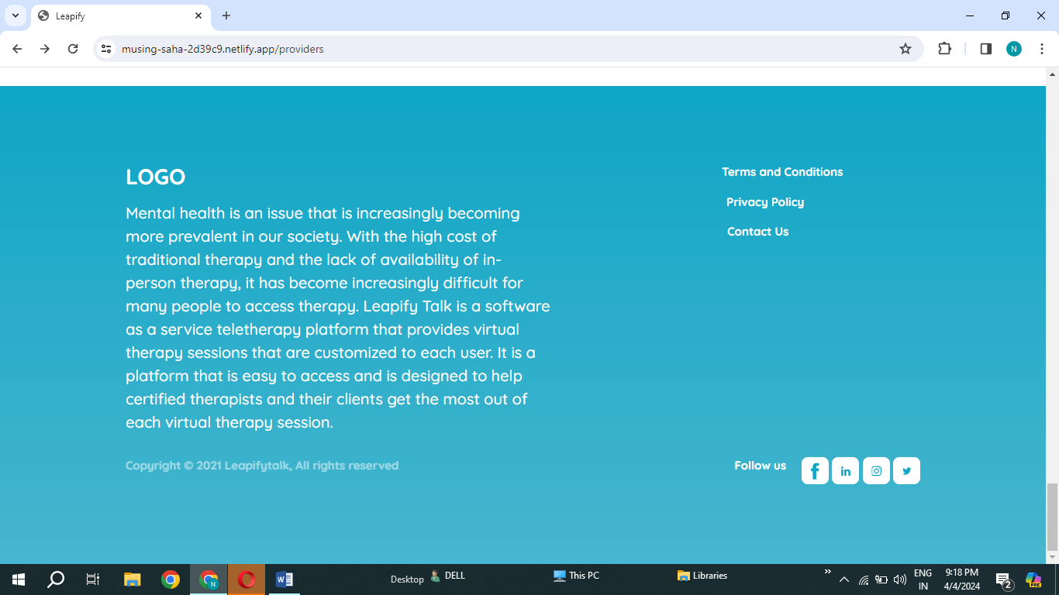

T should be Capital from the Leapifytalk